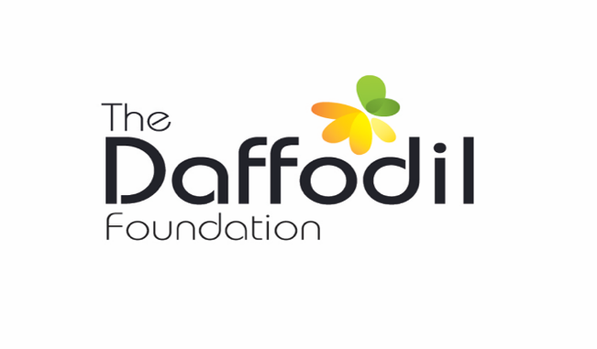

“Supporting & promoting the wellbeing of young people in Ireland”

The Daffodil Foundation was established by Daffodil Care Services (incorporating Social Care Training Ireland) in June 2015. The mission of The Daffodil Foundation is to ‘support and promote the wellbeing of young people in Ireland’

One of our key focuses for this period is to support young people leaving residential care, and providing needs assessed financial assistance with their transition to independent living

Aftercare Award Criteria

The Application process requires an organisation to return a completed application form (below) setting out on a needs assessed basis, the nature of the support required. Once approved, funding will be provided to a maximum of €350. Applications can be made from 3 months pre leaving care to 12 months post leaving care.
One application per person will be accepted.

Examples of requests include:
- Preparation for education and purchase of books, stationary, printing cards, school bag etc.
- Preparation for employment and purchase of appropriate clothing, LEAP card top-up, passport, driving lessons etc.
- Preparation for independent living and purchase of starter kit i.e. pots and pans, furniture, electricity meter card etc.
- Assistance for those accessing homeless services i.e. appropriate clothing for rough sleepers, sleeping bags, toiletries etc.

Terms and conditions will apply including a requirement for the Key Worker and Young Person to sign off on funds received and confirm that funds were used against identified needs as stated in the application. Documentary evidence should be supplied where possible.

A follow-up (3 Month) report should be supplied identifying the benefit and/or outcome resulting from the award with feedback on the effectiveness of the grant. This will offer the opportunity to assess, monitor and amend the application process and criteria for award.

The Daffodil Foundation invites you on behalf of your Organisation, to make an application for this award by completing the attached form.

Please complete this form and include all information in support.

Section 1 Referring Agency Details:

*Referring Agency *Referring Worker Name

*Agency Address * Workers Employment Address

*Agency/Worker Telephone Number * Agency/Worker email address

Section 2 Applicant’s Details:

* Applicant’s Name * Applicant’s Date of Birth

*Applicant’s Address * Proposed Date of Leaving Care

*Applicant’s Telephone Number * Applicant’s Email Address

Section 3 Purpose of Aftercare Award

Please tick what the Aftercare Award will be used for

Clothing |  | Employment |  | Education |  | Accommodation
Child Care |  | Medical |  | Social |  | Other

In 500 words or less, please detail what this grant will be used for and how it will benefit the applicant:

Section 4 Payment

Total amount requested: €________ (to a maximum of €350)

Please confirm payee organisation name:
(Cheque made payable to sponsoring Agency only)

Please return your completed application form by post to:

The Daffodil Foundation
Daffodil House
Market Street
Thomastown
Co Kilkenny

Or email completed applcation to daffodilcarefoundation@gmail.com

DATE: _______________________________

For any queries or for further information please contact The Daffodil Foundation below daffodilcarefoundation@gmail.com

